* Let’s create a new folder in the working tree/directory
* Git will not detect empty folders as changes because git works with files and paths of files 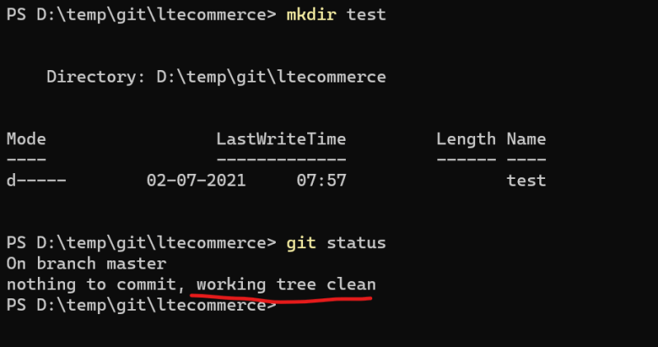
* Lets add some file in the empty directory 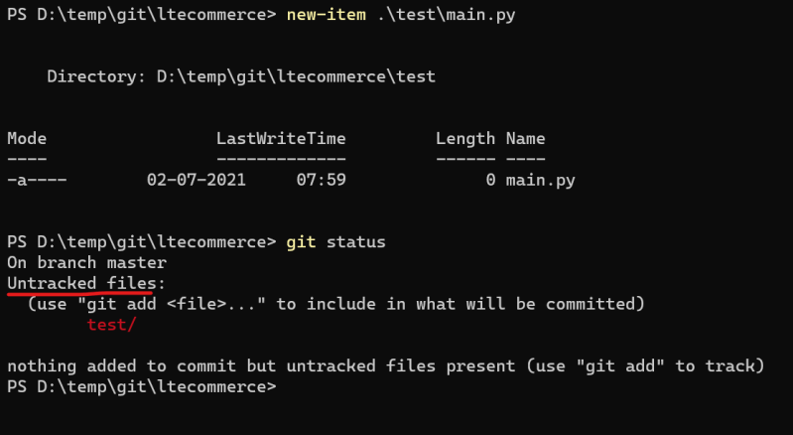
* Now lets make some changes in existing files 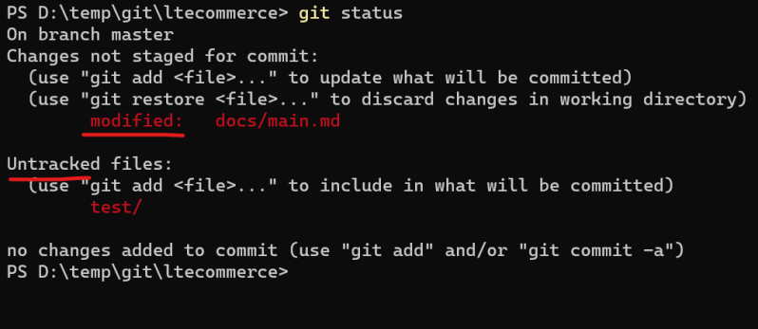
* **Untracked files are the newly added files which are not part of git local repository and modified are the changes done the existing files which are part of git local repository**

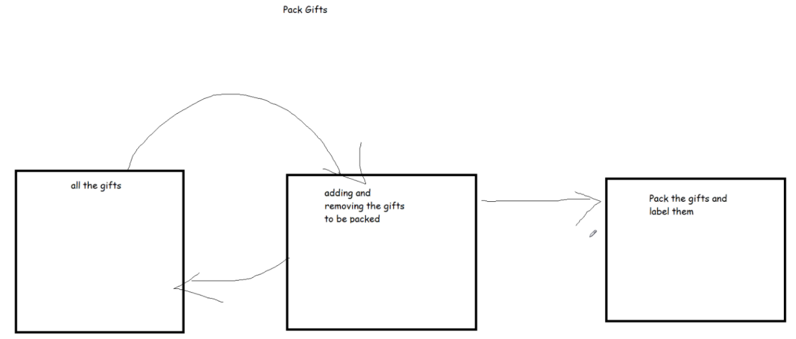

Role of staging area: it performs encryption, and data compression.

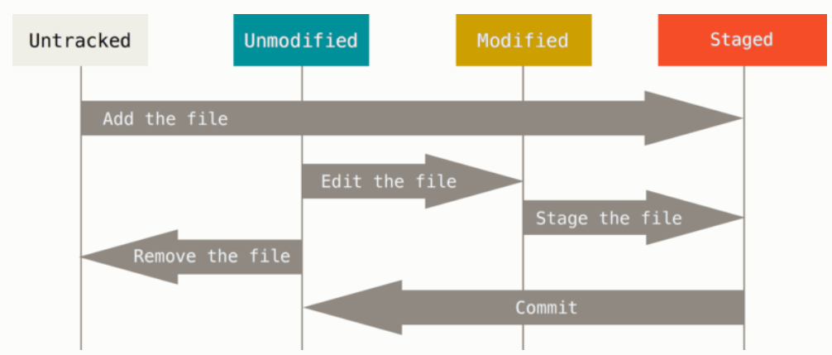

* Now lets add all the changes to the staging area git add -A 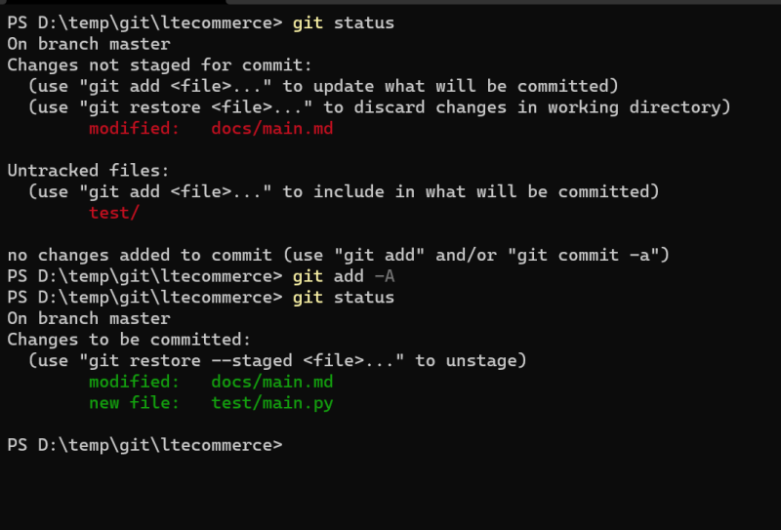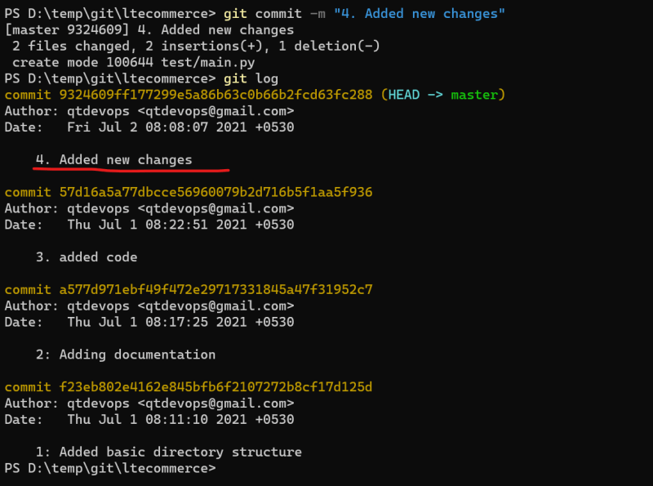
* Adding changes to staging area 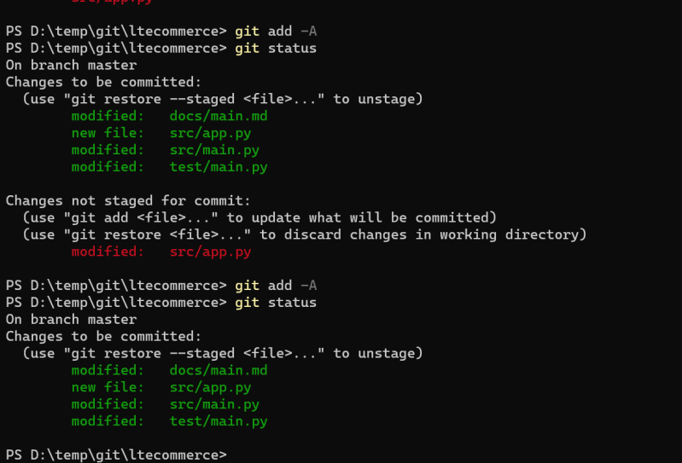
* **Changes can remove from staging area by using reset command. Let’s remove the changes from some file in the staging area** 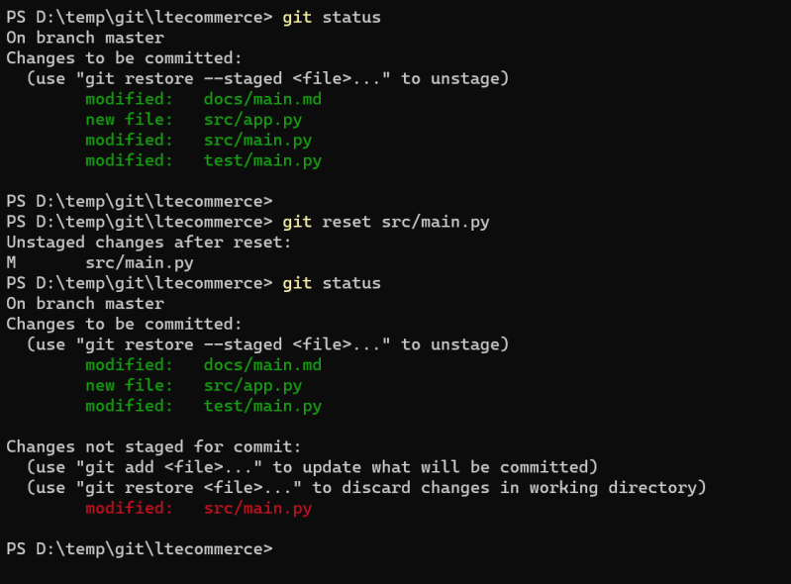
* Now commit the remaining changes in the staging area 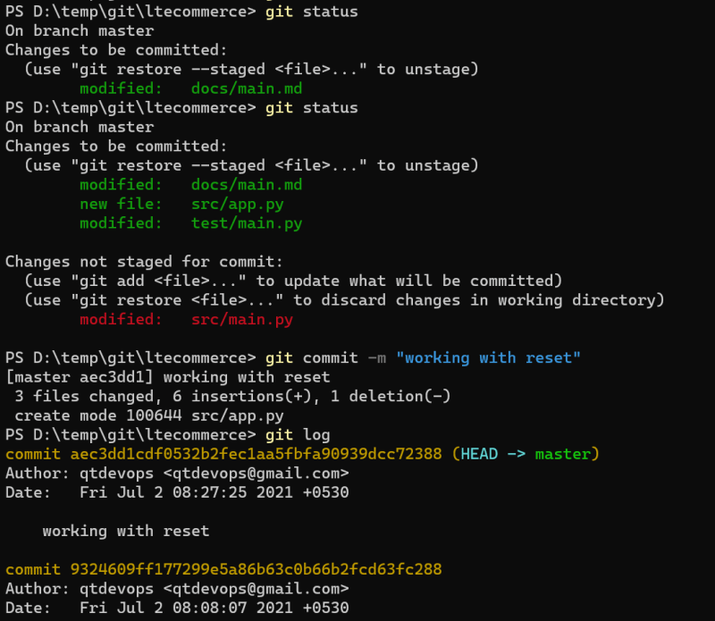
* git restore can be used to remove the modified changes from the working directory
* Lets add 3 new files and add them to staging area. 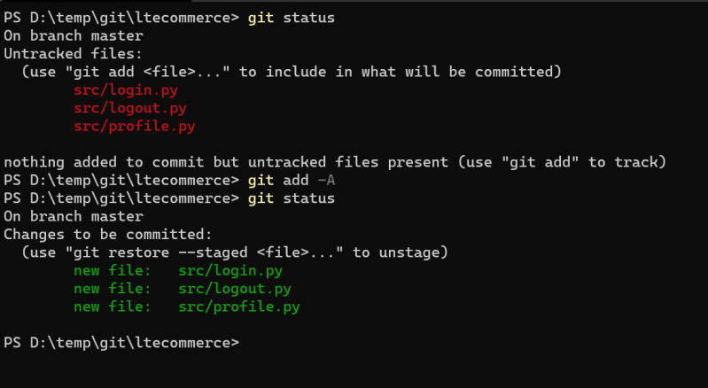
* Now add one change in existing file and add it to staging area 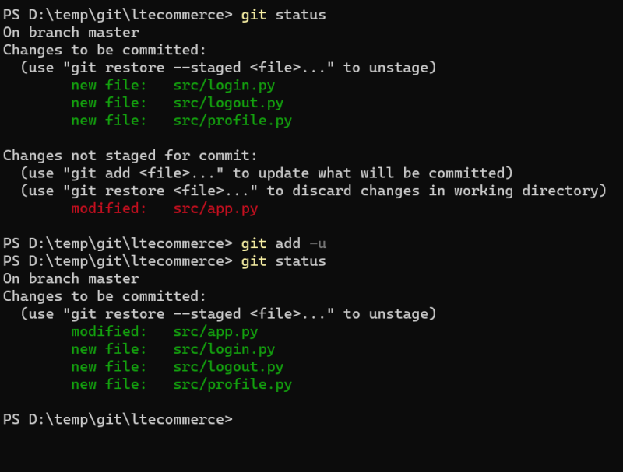
* git reset --hard can be used to move the changes from staging area to working tree and clean the working tree as if no changes have been done. 